GRADE 7 ACCELERATED · UNIT 2 · LESSON 4  Approximating Irrational Numbers  Additional Practice 7A.02.04 | Name_________________________  Date__________________________  Period________________________

1. Find the value of each. If there is no real value, write “no real value.”
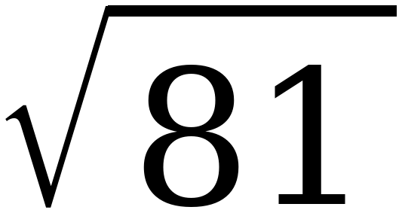 | 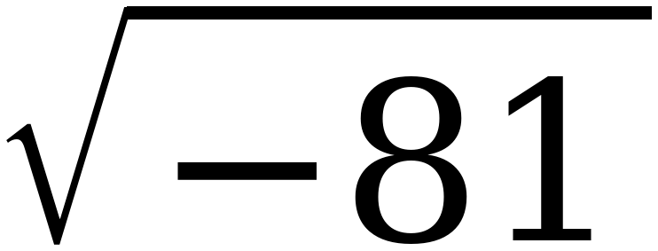 | 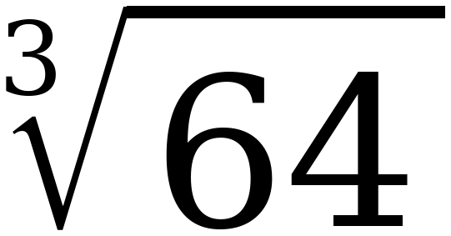 | 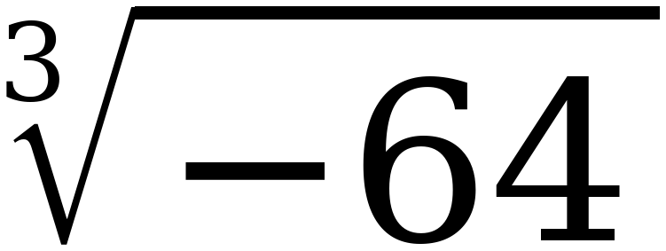

2. Why is there no real value for when there is one for ?

3. Select ALL of the numbers below that are irrational.
☐ | 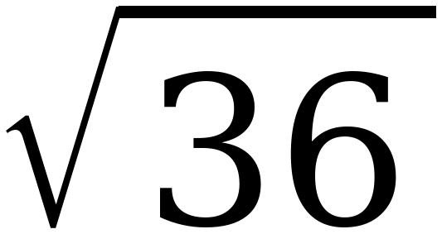 | ☐ | 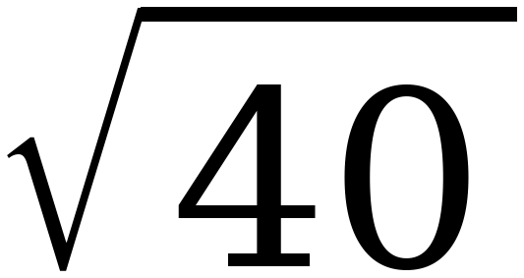
☐ | 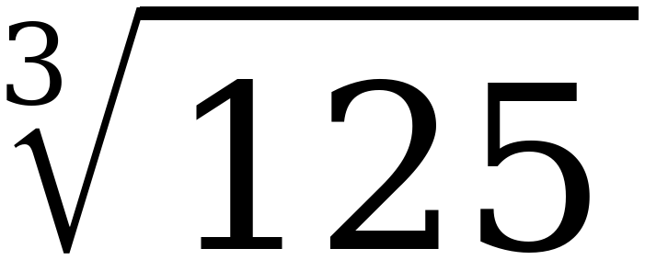 | ☐ | 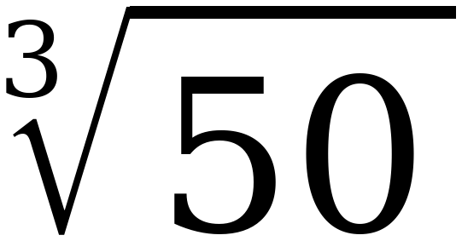
☐ | 2π | ☐ | 

Questions 4 and 5: name the perfect squares or cubes first, then the root.
4. 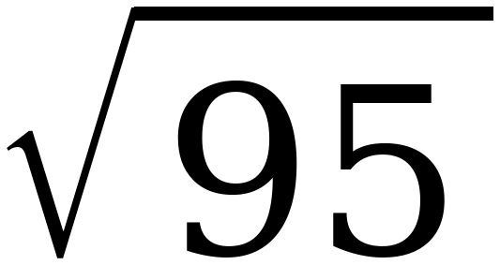
a. 95 lies between the perfect squares ______ and ______.

b. So the root lies between the integers ______ and ______.

c. The root is closer to ______.

5. 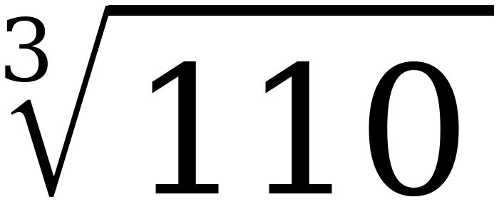
a. 110 lies between the perfect cubes ______ and ______.

b. So the root lies between the integers ______ and ______.

c. The root is closer to ______.

6. Approximate to the nearest tenth. Fill in the table, then decide.
Try | Result | How far from 95
9.7 × itself
9.8 × itself

To the nearest tenth, the value is ______________.
7. Approximate to the nearest tenth. Fill in the table, then decide.
Try | Result | How far from 110
4.7 cubed
4.8 cubed

To the nearest tenth, the value is ______________.
8. Use ≈ 9.747 to approximate each expression to the nearest tenth.

Expression | Approximate Value
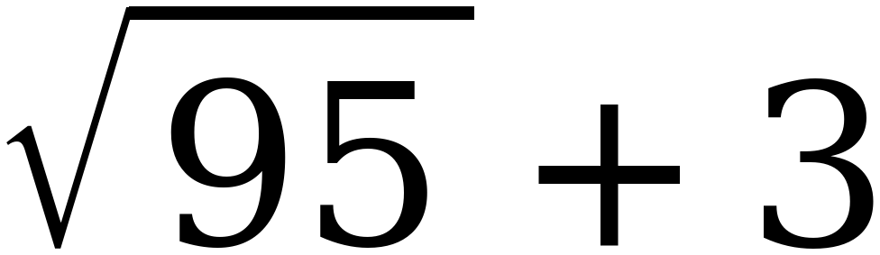
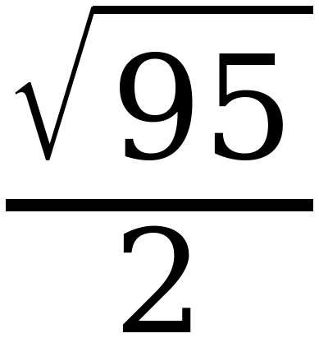
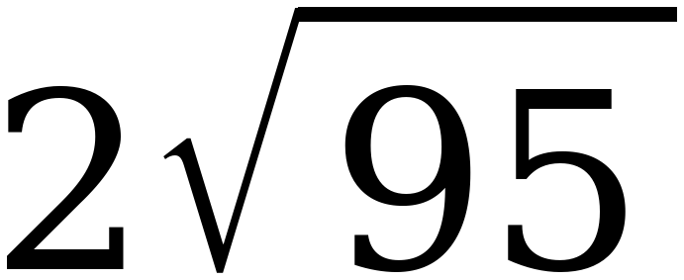

9. Approximate the value of each expression to the nearest tenth.

 | Expression | Approximate Value
A
B | 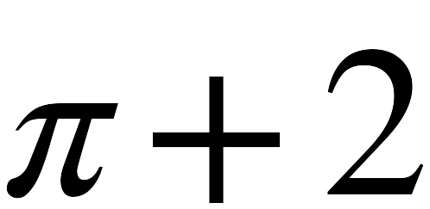
C | 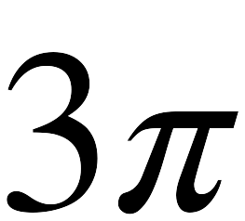
D

10. Plot and label A, B, C and D on the number line.
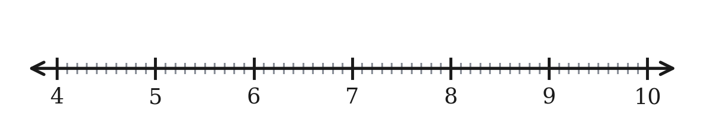
11. Marcus says that because 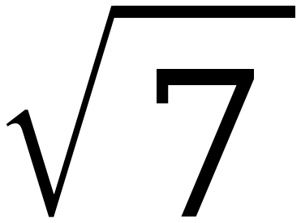 ≈ 2.6, the value of 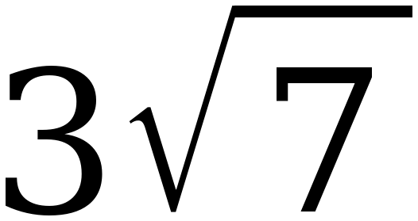 is 7.8. His calculator says 7.9. Who is right, and what went wrong?

